**Student Written Assessment (Airport Maintenance Assignment (Part 1))**

|  |  |  |  |
| --- | --- | --- | --- |
| **Business Unit/Work Group** | IT Studies | | |
| **Qualification Code** | National Code: ICT50715 | **Qualification Title** | Diploma of Software Development |
| **Unit Code/s** | ICTDB502 | **Unit Title/s** | Design a Database |
| **Assessment Task Title** | **5DD Airport Maintenance Assignment( Part 1)** | | |
| **Student Name** | Submit your solution via your LEARN account | **Student SIS ID** | Submit your answers via your LEARN account |
| **Assessor Name** | You have been added to a LEARN group which defines your assessor. This is normally your Course Registration Number (CRN) lecturer. | **Date** | 2019 Semester 1 |

|  |  |
| --- | --- |
| **Student Guide for Practical Assessment** | |
| **Overview of Assessment** | This assessment will require you to complete several sections requirements for the Southern Airport Maintenance database. Each section has multiple parts require you to complete.  In this assessment you will cover the following topics:   * Determine the database requirements * Develop a logical data model * Design index and develop data dictionary * Estimate the size of the database * Design multi-user access, security & encryption * Backup and recovery   The assessment is broken into 3 separate submissions (SECTION A, SECTION B, SECTION C ~ F plus Merit section) and you will submit the solution by the assessment due date. |
| **Task/s to be assessed** | This part of the assignment requires you to design a conceptual database, logical database and consider some physical aspect of the database such as sizing, indexing for performance and backup & recovery procedures. The following pages will define the specific tasks you need to complete. |
| **Time allowed** | You have the whole course duration to complete this exercise, however there several sections have their own submission date. You should adhere to these dates so that you get a balanced work load throughout the semester.  The submission date is provided in the LEARN course and summarized in the Assessment Submissions topic in LEARN. |
| **Location** | You can complete this assessment during your practical sessions and at home. |
| **Decision making rules** | To receive a satisfactory outcome for this assessment you must complete all tasks and parts correctly. |
| **Assessment conditions** | You must use the provided format/symbols for the notation for ERD, relational database schema, data dictionary – attribute specification & functional dependency in completing this assessment. |
| **Resources required** | None. |
| **Results/Re-assessment** | You will be provided feedback for each task of the assessment and be given the opportunity to resubmit with any required corrections only once. |
| **Submission Instructions** | The exercise can be found in the Assessment Submission Topic on LEARN. Your solution is required to upload to LEARN. |

**Airport Maintenance Assignment (Part 1)**

# Scenario:

Southern Airport officials decided that they need a new Database to manage the aircraft maintenance & technical information and you have been hired to design this database. The existing system was developed 15 years ago with the windows-based application. The functions do not meet the requirements of the aircraft maintenance today. Therefore, the airport was using some manual systems to help the meet the daily maintenance operations. The human resources management was even a different system that has been out-sourced their development and operation to a service provider. The human resources staff only maintain the staff information by inputting and updating staff details and run reports only.

This is the stage 1 of the development. This stage is mainly to design the conceptual & logical design of the database structures. Define the tables structures. Create the database schema and tables required. Estimate the size of the database. Design the user security and the backup recovery procedures. The scope of the database information shall include the technical information about all aircrafts stationed and maintained at the airport, as well as part of the human resources related with staff training and testing activities. The stage 1 will not implement the database with data conversion, operation with intensive performance testing and monitoring. That will be the stage 2 of the development which will be regarded as out of the scope at this stage.

The initial analysis conducted 3 months ago has captured the following information.

Each country has many airlines. Each country is identified by a country code and has country name. Each airline has a certain home country where it is flying from.

Each aircraft must be owned by one and only one airline. Each airline may own many aircrafts.

Each airline is identified by the airline ID which is the IATA-Code (2 characters). It has a unique name. The system shall also keep track of the airline information with their address (i.e. includes information of street, suburb, postcode, state and country name), contact phone and fax number and their internet website.

The airport has a maintenance unit which maintains aircrafts. The unit needs to store the aircraft information of every aircraft maintained here. Each aircraft is identified by a unique aircraft id number. To fly internationally, it must have an international registration number. These registration number is commonly known and consist of a two-letter code identifying the owning airline and a three letter unique id within the airline fleet. Both parts are separated by a hyphen. For example, ’VH-OJA’ would be a valid aircraft registration number. ’VH’ is the code for the Qantas fleet of aircrafts and ’EAF’ identifies one particular aircraft of the Qantas fleet. Most airlines give their aircrafts a name. For example, as mentioned ’VH-EAF’ is named ’City of Adelaide’ by Qantas.

Each model of aircraft has a unique model code (e.g. ’A380’ or ’B747’) and is produced by a specific maker (e.g., ’Airbus’, ’Boeing’ or ‘Gulfstream’). The model code typically may contain some indication of the maker (e.g. all model names used by Boeing start with a ’B’), a model number (such as 747 or 380).

Each model must have at least one or many sub-models. Each model of aircraft has a unique model name (e.g. ’A380-800’ or ’B747-400 ER’). A sub-model code that allows to differentiate different variants of a plane model. For example, a ’B747-400 ER’ is the extended range version of the latest version of the Boeing 747, as is ’A380-900’ a specific variant of an Airbus A380. Each sub-model must belong to one model.

Every aircraft must belong to a sub-model which the airport must be licensed to accommodate because of runway issues. The airport maintenance unit needs to keep track of several technical details of each model of aircraft such as width, length, height, wing span area, maximum cruising speed, maximum range, required take off distance & required landing distance.

Each sub-model is designed to use one or many engine options, each engine model used may affect the engine weights, the take-off weight and also the aircraft net weight.

For example:

|  |  |
| --- | --- |
| **Sub-model:** | Boeing747-100 |
| **Engine Models:** | (1)JT9D-7A（20,925kg） (2)CF6-45A2（20,925kg） (3)RB211-524B2(22,545kg) |
| **Width:** | 59.64m |
| **Length:** | 70.66m |
| **height:** | 19.33m |
| **Wing Span Area:** | 511.0m2 |
| **Maximum Take Off Weight:** | (1)334,757kg (2)322,050kg (3)322,050kg |
| **Net Weight:** | (1)170,000kg (2)170,097kg (3)172,818kg |
| **Maximum Cruising Speed:** | Mach 0.85 |
| **Maximum Range:** | 8,895km |
| **Required Take Off Distance:** | 3,050m |
| **Required Landing Distance:** | 1,942m |

|  |  |
| --- | --- |
| **Sub-model:** | Boeing747-200B |
| **Engine Models:** | (1)JT9D-7R4G2（24,635kg） (2)CF6-50E2（23,850kg） (3)RB211-524D4(23,850kg) |
| **Width:** | 59.64m |
| **Length:** | 70.66m |
| **height:** | 19.33m |
| **Wing Span Area:** | 511.0m2 |
| **Maximum Take Off Weight:** | (1)377,840kg  (2)377,840kg (3)371,945kg |
| **Net Weight:** | (1)170,097kg (2)171,911kg (3)174,633kg |
| **Maximum Cruising Speed:** | Mach 0.85 |
| **Maximum Range:** | 12,700km |
| **Required Take Off Distance:** | 3,170m |
| **Required Landing Distance:** | 2,109m |

Each aircraft must be operated as a sub-model category either as a passenger airliner or a cargo freighter. Most technical details are in common for both of those categories. A passenger category or freight category is a kind of sub-model. However, a passenger category has a maximum number of passengers. A cargo category (e.g. the ’Airbus A300-600ST’) is designed to carry only cargo and hence has a maximum cargo weight.

See the following for the details the maintenance unit wants to store for a passenger aircraft.

For example: Singapore Airline, Airbus A380-800

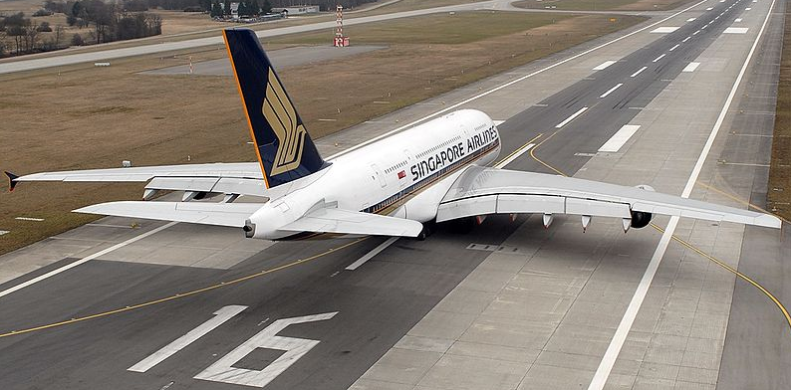

With regard to the human resources, the system needs to record the technician information. Each technician is uniquely identified by their employee id. You need to store the name (both given and family name), address (street, suburb, postcode), phone, salary and their login name. Each technician is a qualify expert on one or more model aircrafts (but not more than three). Each model has 0, 1 or many qualified technicians. This information about technicians must also be recorded. Each technician is managed by a manager. Each manager may manage 0, one or many technicians. The manager has all the information of the technician, plus the team name and the date that he starts to become a manager.

The airport maintenance has many kinds of tests that are used periodically to ensure that aircrafts are still airworthy. Each kind of test has a Civil Aviation Safety Authority (CASA) test number, a description of the test. Each kind of test has many defined test items which is identified by an item code and has information of item description.

Each test event is identified by the test event id, the date/time start the test, the date/time end the test, the number of hours the technician spent test, pass/fail the test, and the result comments. Each aircraft may book for many test events. Each test event carries out only one specific kind of test. The CASA requires the airport to keep track of each aircraft being tested under a certain test event by a given technicians.

If a test event is failed, it may lead to a sequence of subsequent test events. All these subsequent tests must be traceable to the original test so that summary report can be generated.

**Requirements**

Given the Airport Maintenance Scenario (See **5DD_Airport_Maintenance_Assignment (Part 1)_190210.docx**), you are required to carry out the following tasks:

**SECTION A (Determine the database Requirements)**

Meet the client to analyse the database functionality

You must participate in the workshop in the Session 3. You will meet the client (your lecturer) to revise the requirements of this database process. You need to document the following items:

1. Describe what management information can be obtained from the Southern Airport aircraft maintenance database.

* How many airplanes belong to an airline.
* Technicians who are qualified to maintaining a specific aircraft model
* Airport needs to know who is qualified to maintain a specific aircraft model
* Each aircraft model may have different airplanes
* Technician trained for specific aircraft model
* Regular tests to ensure aircraft is suitable for flight
* Test events that the aircraft needs to book in
* Trace every test event result to ensure each aircraft has done testing
* Must know who the managers of the technician are
* Display which aircraft belong to which airline
* Display technical details of the aircraft (what engine, model, flight noise level)

1. List the phases of the database life cycle involved in the stage 1.

**Capture requirements Form:** Initial design (conceptual design) known as requirement analysis process

**Logical design process:** Refining and detailing the design issues related to the detail of ERD’s, the logical mapping of the ERD into logical data structures in a relational database.

**Physical Design:** Designing the data structure and indexing of the database. Size of database and so on.

1. List the design documents that you will produce for each phase of these database life cycle involved.

* Conceptual design (requirement analysis stage)
  + Conceptual ERD
* Logical design
  + logical ERD
  + logical data structure
  + functional dependency diagram
  + database schema.
  + Document data dictionary: Attribute specification, entity specification
* Physical design process
  + list indexes being used to improve retrieval speed
  + calculate size of database

1. Produce a conceptual model of the database. i.e. the draw ERD focus on identifying the entities and the relationships between them. No need to detail the non-key attributes at this stage. Use MySQL Workbench to model the database called “**SouthernAirportDB**”.

How To:

How to: Need to draw an ERD for the southern airport database.

Just want relationship between entity, identify what entity is needed i.e. the tables needed

Then form the relationship between the entities using the business rules described in the case scenario e.g. each of the aircrafts belong to one aircraft at a time AND each airline owns many aircrafts. Then form the 1:M between these.

Due to the workbench being used, you must define the PK being used by these entities so that you can link between the entities. Need to include the PK.

Conceptual model does not need much of the non-key attributes.

Just provide the right relationship between the right entities for the conceptual model.

Singular, No plurals in entity names

*Note: You must**configure the MYSQL Workbench to use the crow’s foot notation and* ***relevant naming convention specified as in Session 3****. Show the name & the caption of each relationship identified.*

**Submission:**

Submit all parts of the **SECTION A** by the due date specified by the Assessment summary. You are expected to submit a word document and ERD diagram file for marking and comments.

*Note: oral communication observation assessment will be conducted during the requirement capturing workshop, as students are communicating with the lecturer and also with students each other. Please look at the oral communication assessment criteria on Moodle.*

**SECTION B. (Logical data modelling)**

1. Write **all** of the **business rules** that support your ERD. On top of the **business rules**, you also need to write any additional **assumptions** that you have made.

e.g. Each airline owns 0,1 or many aircraft(s).

Each aircraft must be owned by one and only one airline.

……………………………..

…………………………….. etc.

Each country has zero, one or many airlines

Each airline must belong to one and only one country

Each airline has one and only one address

Each address specifies one and only one airline

Each airline contains zero, one or many aircrafts

Each aircraft must be owned by one and only one airline

Each aircraft must be operated as a sub-model category either as a passenger airliner or a cargo freighter

Each sub-model identifies one or many aircrafts

Each aircraft can have zero, one or many engines

Each engine must belong to one and only one aircraft

Each engine belongs to one and only one engine model

Each engine model identifies one or many engines

Each sub-model is designed to use one or many engine models

Each engine model is used in one and only one sub-model

Each sub-model belongs to one and only one model

Each model identifies one or many sub-models

Each model is managed by one or many technicians

Each technician specialises in one or many models

Each technician has one and only one technician address

Each technician is supervised by one and only one technician

Each technician can supervise zero, one or many technicians

Each technician can have zero or one manager

Each technician can manage one or many test events

Each test event is managed by one and only one technician

Each test event has zero, one or many test items

Each test item belongs to zero, one or many test events

Each test must be traceable to the original test event

Each test event belongs to one and only one test

Each test contains one or many test events

Each test contains one or many test items

Each test item belongs to one and only one test

1. Further develop your **ER Diagram** to produce a logical model of the database.

*In you ERD, pay attention to the following design issues.*

* *Revise the conceptual Model, make sure that the relationships are related with the correct entities.*
* *All entities must be named singular*
* *Configure the Workbench ERD Model to display the relationship caption. All relationship names are capitalised the first latter and camel case.*
* *All entities must have a primary key (i.e. can be single column or multiple columns).*
* *Consider using the surrogated PK or not. Should the PK be auto increment?*
* *Determine the cardinality & participation constraints according to the business rules for each relationship.*
* *Use non-identifying relationship / identifying relationships appropriately.*
* *Add attributes to meet the need of the business operations.*
* *Ensure the table is normalised. i.e. every non-key attribute must be full functional depending on the primary key*
* *Ensure that there is no multi-values exists in the attribute.*
* *Ensure the foreign keys constraints are correct (i.e. must be the same data type)*
* *Consider null /not null for each attribute in each entity.*
* *Consider default, unique, sign/unsign and the limited values (if any)*
* *Consider the super-type and sub-type relationship if appropriate.*
* *Consider any recursive relationship if appropriate*
* *Consider to split a complex data structure into separate data field so that they can be accessed independently. e.g. Name becomes FirstName, LastName. Similarly for Address need to break down into separate field.*
* *Consider the parental constraints and referential integrity (i.e. cascade update & delete issues)*

1. Generate and execute the create table database schema sql script. Capture the screen shots as evidence that you have successfully created the database and the tables designed.

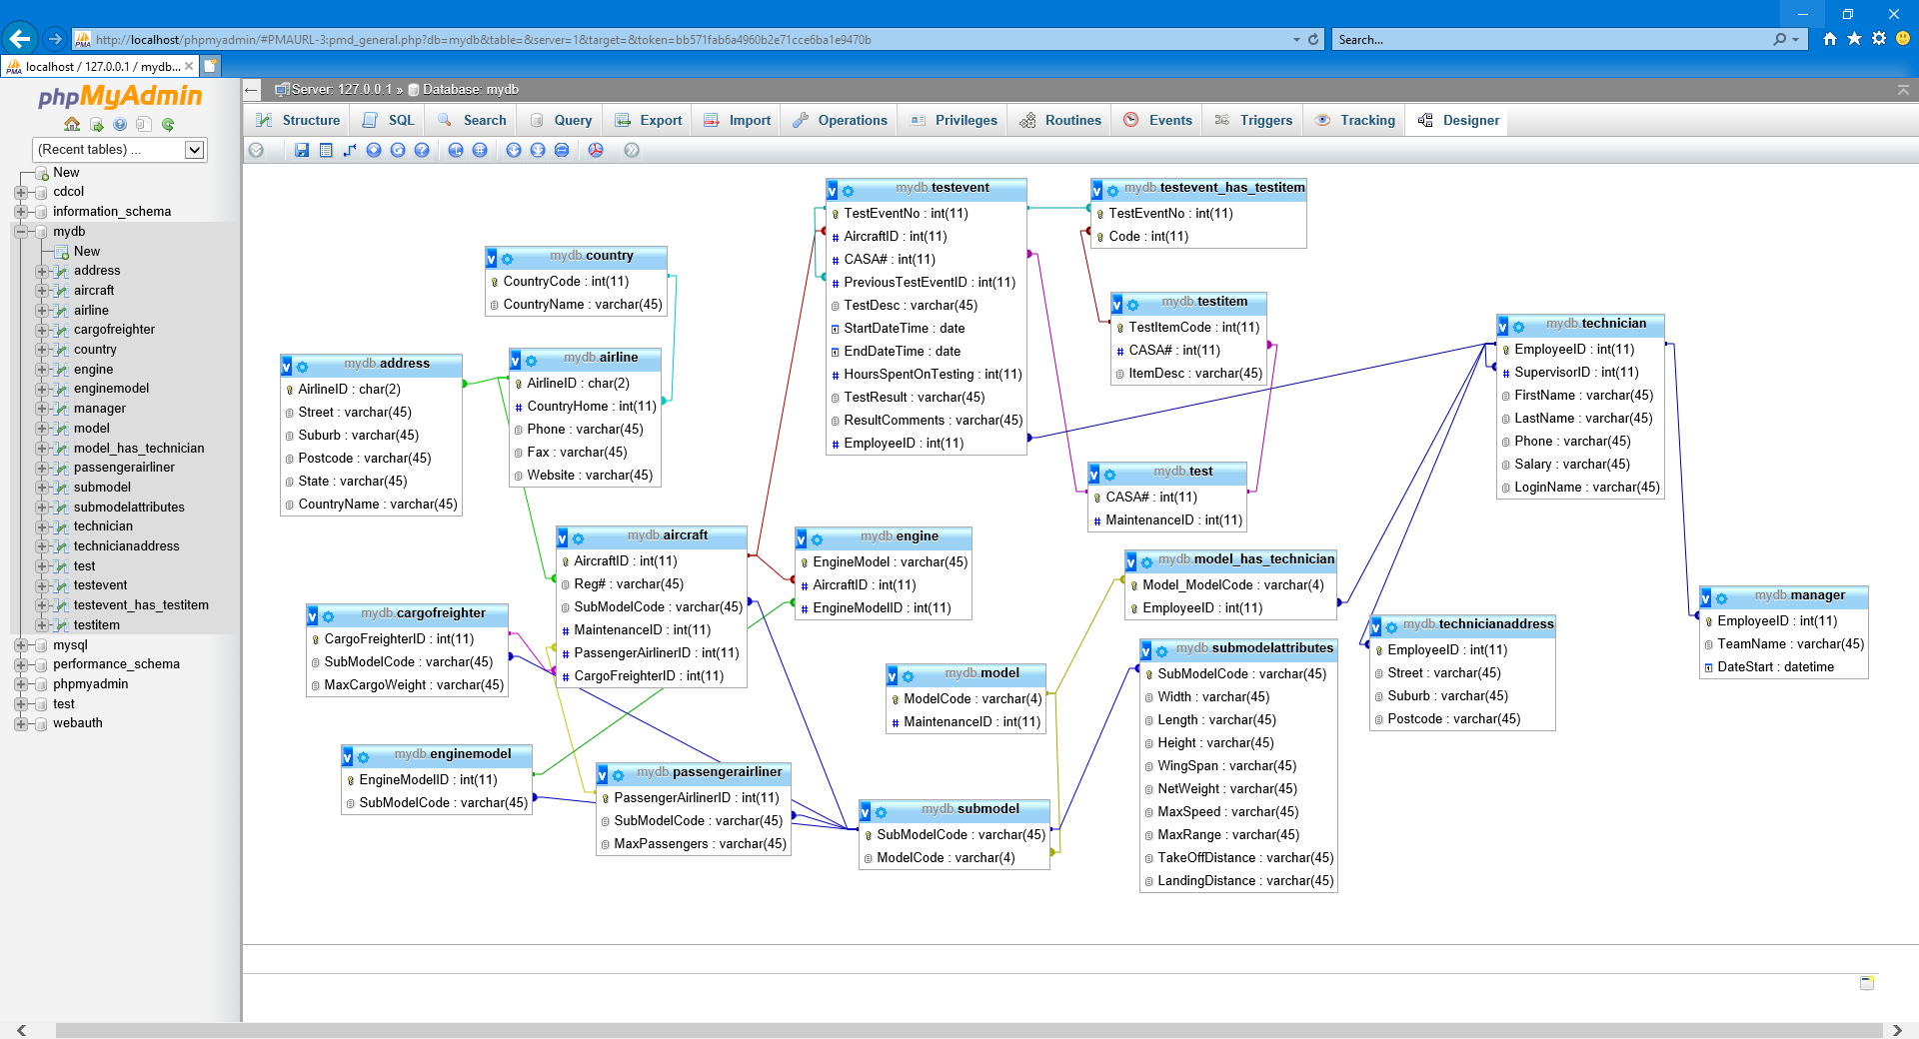

**Submission:**

Submit all parts of the **SECTION B** by the due date specified by the Assessment summary. You are expected to submit a word document with the business rules, ERD diagram file and the sql script file to Moodle for marking and comments.

*Note: You are required to present your Assignment (Part 1 SECTION B), oral communication observation assessment will be conducted as students are communicating with the lecturer and also with students each other. Please look at the oral communication assessment criteria on Moodle.*

# SECTION C. (Design Indexes & Data Dictionary)

1. Indexes are best used on the columns that are frequently used in the where clause, sorting with the ‘order by’ in the sql queries. The primary keys and the foreign keys are automatically indexed for MySQL innodb.

The management has highlighted that they have indicated a frequent used query on who are the technicians has done the training for a certain aircraft model. The query will need to join multiple tables together with the condition of the ‘aircraft model id’. The output is expected to be sorted with the technician ‘firstname’ and ‘lastname’ in ascending order.

1. Suggest which columns (i.e. single column or multiple columns) should be indexed in order to give a better performance to the query.

Multiple columns

1. Write the CREATE INDEX statements to create the indexes as required.

Capture the screen shots as evidence that you have successfully created those indexes needed. 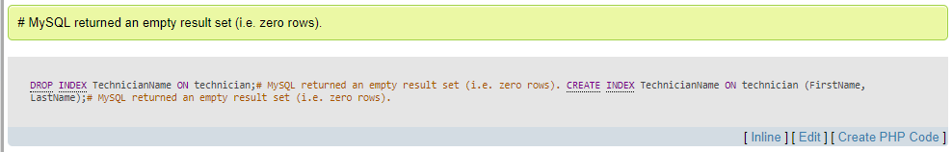

1. Create database schema for the data base.
2. Map the ERD to logical data structure. List **all** tables in the following relational logical data structures. Note: must indicate the PK (in bold) and FK (in italic)

e.g. AircraftModel_Technician (***ModelCode, EmpID***, QualifiedDate)

Country (**CountryCode,** CountryName)

Airline (**AirlineID,** *CountryHome,* Phone, Fax, Website)

Address (***AirlineID,*** Street, Suburb, Postcode, State, CountryName)

Aircraft (**AircraftID,** *Reg#, SubModelCode, PassengerAirlinerID, cargoFreighterID)*

CargoFreighter (**CargoFreighterID,** *SubModelCode,* MaxCargoWeight)

PassengerAirliner (**passengerAirlinerID,** *SubModelCode,* MaxPassengers)

SubModel (**SubModelCode,** *ModelCode*)

SubModelAttributes (***SubModelCode,*** Width, Length, Height, WingSpan, NetWeight, MaxSpeed, MaxRange, TakeOffDistance, Landing Distance)

EngineModel (**EngineModelID,** *SubModelCode*)

Engine (**EngineModel,** *AircraftID, EngineModeID*)

Model (**ModelCode**)

Technician (**EmployeeID,** *SupervisorID*, FirstName, LastName, Phone, Salary, LoginName)

Model_has_Technician (***ModelCode, EmployeeID***)

TechnicianAddress (***EmployeeID,*** Street, Suburb, Postcode)

Manager (**EmployeeID,** TeamName, DateStart)

Test (**CASA#**)

TestEvent (**TestEventNo,** *AircraftID, CASA#, PreviousTesteventID,* TestDesc, StartDateTime, EndDateTime, HoursSpentOnTesting, TestResult, ResultComments, *EmployeeID*)

TestItem (**TestItemCode,** *CASA#,* ItemDesc)

TestEvent_has_TestItem(***TestEventNo, TestItemCode***)

1. Use the following format for the Relational Database Schema. For the simplicity of the assignment, you are required to document at least **three** tables.

**Relational Database Schema:**

|  |  |  |  |
| --- | --- | --- | --- |
| **Table Name** | **Field Name** | **Data Type** | **Relational Description** |
| AircraftModel_Technician | ModelCode  EmpID  QualifiedDate | INT  INT  Date | PK, FK Reference AircraftModel (ModelCode)  PK, FK Reference Technician(EmpID) |
| TestEvent_has_TestItem | TestEventNo  TestItemCode | INT  INT | PK, FK Reference  TestEvent (TestEventNo)  PK, FK Reference  TestItem (TestItemCode) |
| Engine | EngineModel AircraftID EngineModelID | VARCHAR  INT  INT | FK Reference  Aircraft (AircraftID)  FK reference  EngineModel (EngineModelID) |
| CargoFreighter | CargoFreighterID  SubModelCode  MaxCargoWeight | INT  VARCHAR  VARCHAR | FK Reference  SubModel (SubModelCode) |

1. Create a data dictionary - the attribute description

Use the following format for the Attribute Description. For the simplicity of the assignment, you are required to document at least **three** attributes.

|  |  |
| --- | --- |
| **DATA DICTIONARY: – ATTRIBUTE DESCRIPTION** | |
| SYSTEM : Southern Airport Maintenance | DATE: 03/02/2018 |
| AUTHOR : John Smith | PAGE: 1 of 1 |
| ATTRIBUTE NAME (EmpID): Employee number | |
| ALIAS (Synonym) : EmpCode | |
| DATA SOURCE: Technician | |
| **DATA STRUCTURE** | |
| Type: INT | |
| Length and Format: 999999 | |
| Characteristics | |
| Range of Values  000000 ~ 999999 | |
| DESCRIPTION  It is a six digit employee number.  The number is auto increment.  Includes the part-time, full-time employee & contractors who work with the team. | |

|  |  |
| --- | --- |
| **DATA DICTIONARY: – ATTRIBUTE DESCRIPTION** | |
| SYSTEM : Southern Airport Maintenance | DATE: 05/05/2019 |
| AUTHOR : Christian Micallef | PAGE: 2 of 1 |
| ATTRIBUTE NAME (AirlineID): Airline ID | |
| ALIAS (Synonym) : AirlineCode | |
| DATA SOURCE: Airline | |
| **DATA STRUCTURE** | |
| Type: CHAR | |
| Length and Format: AA | |
| Characteristics | |
| Range of Values  AA ~ ZZ | |
| DESCRIPTION  It is a two-character airline code.  The character represents is an IATA-Code.  Stores airline address and contact details. | |

|  |  |
| --- | --- |
| **DATA DICTIONARY: – ATTRIBUTE DESCRIPTION** | |
| SYSTEM : Southern Airport Maintenance | DATE: 05/05/2019 |
| AUTHOR : Christian Micallef | PAGE: 2 of 1 |
| ATTRIBUTE NAME (TestEventNo): Test Event Number | |
| ALIAS (Synonym) : TestEventNo | |
| DATA SOURCE: TestEvent | |
| **DATA STRUCTURE** | |
| Type: INT | |
| Length and Format: 999999 | |
| Characteristics | |
| Range of Values  000000 ~ 999999 | |
| DESCRIPTION  It is a six-digit Test Event number.  The number is auto increment.  A set of tests to ensure the aircraft is suitable for flight.  Stores previous TestEventNo for reference which includes test result. | |

|  |  |
| --- | --- |
| **DATA DICTIONARY: – ATTRIBUTE DESCRIPTION** | |
| SYSTEM : Southern Airport Maintenance | DATE: 05/05/2019 |
| AUTHOR : Christian Micallef | PAGE: 3 of 1 |
| ATTRIBUTE NAME (AircraftID): Aircraft ID | |
| ALIAS (Synonym) : AircraftCode | |
| DATA SOURCE: Aircraft | |
| **DATA STRUCTURE** | |
| Type: INT | |
| Length and Format: 999999 | |
| Characteristics | |
| Range of Values  000000 ~ 999999 | |
| DESCRIPTION  It is a six-digit aircraft number.  The number is auto increment.  Contains the aircraft registration number along with its sub model code, identifying  whether it is a “Passenger Airliner” or a “Cargo Freighter” | |

1. The users lodged a new requirement asking for a data entry screen for staff to enter aircraft testing information. Each aircraft must test regularly. When an aircraft attends a test event, the staff will need a data entry screen to do the following:

* Enter the Airline Code, the Aircraft code. The Aircraft nmame, aircraft model and sub-model will be displayed on screen for reference.
* The user will enter the information of the test start date and the Test manager code, the system will display the manager name.
* The user will enter the IATA Test code, the system will populate the Test item codes and their description on screen.
* The user will enter the test item results. Each test item can either be ‘pass’ or’ fail’. The corresponding technician no. will be entered against the test item that they have conducted. The technician license no and the date that they sign the signature.
* The user will enter the overall test result (Pass or fail). If the test is a subsequent test which is led by the failing of the previous test. The previous test number will be entered

Design an input screen to fulfil the user input/output requirement for entering the aircraft test result.

In your screen design process, you may experience that your data model may have some data attributes missing, attribute names not matched etc. You need to make sure that your table structures have enough data to support the input screen operation.

Submit your design of the data entry screen together in a word document. 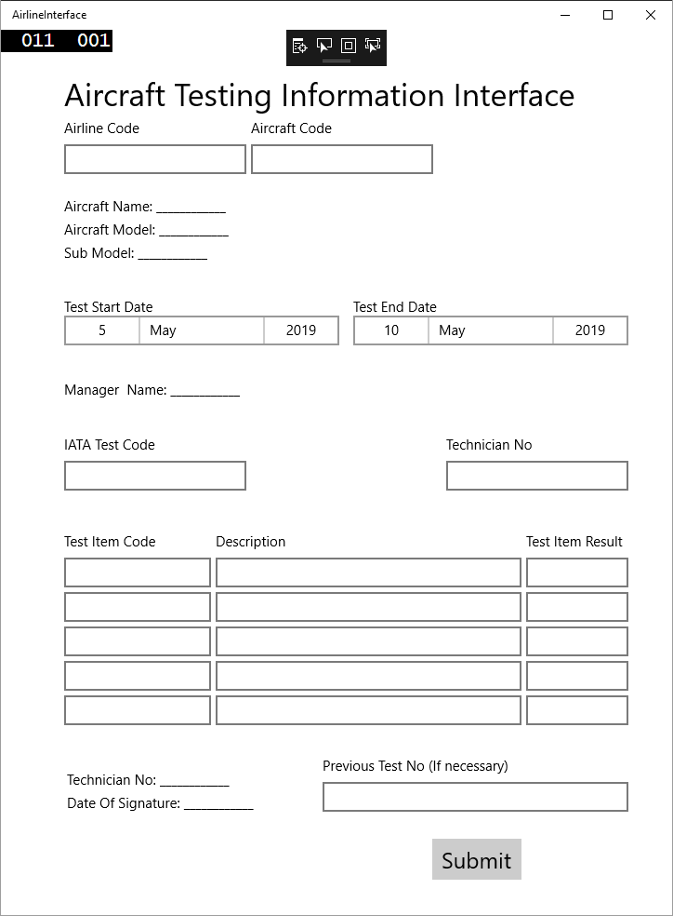

**SECTION D. (Estimate the size of the database)**

1. You are required to estimate the size of the following tables with indexes.

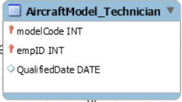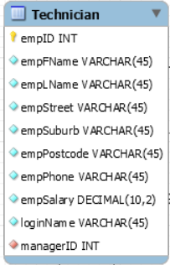

In order to avoid the repetition of calculation for the size of the whole database, we just estimate the size of these two tables. we assume there are 100 Technician records and 800 AircraftModel_Technician records in the database. Estimate size of these tables and their indexes.

Show the steps of your calculation. Note: In your calculation, for simplicity, no need to factor for the housekeeping for BTREE or Tablespace Fragmentation. The page size is default at 16K = 16384 bytes.

ESTIMATING DATABASE SIZE

CHECK SIZES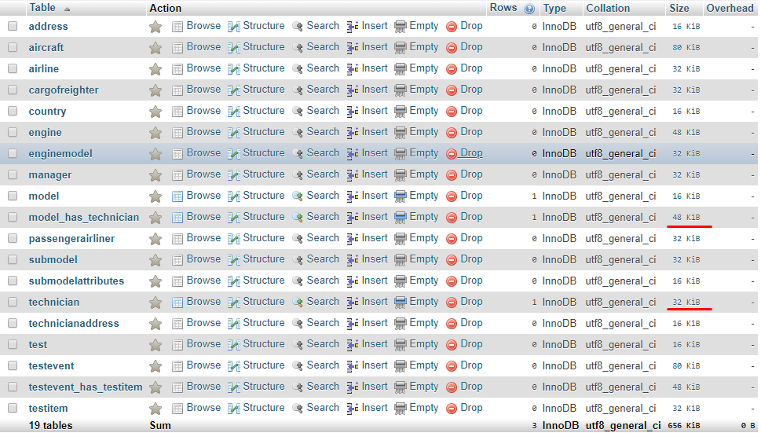

CALCULATE

Technician

Technician = 32KiB x 100

Technician = 3200KiB

Model_has_technician

Model_has_technician = 48KiB x 800

**SECTION E. (Design multi-user access, security & encryption/authentication)**

1. You are required to implement the following database security features.
2. Connect as the root user, use SQL Control Language to create two users. One user is called **‘Joe’** with the password **‘Brown’**. James is the supervisor. The Other user is called **‘Jill’** with the password **‘White’**. June is the clerical support person. Use the root user to grant **Joe** with all privileges to all tables. Grant **Jill** with SELECT and UPDATE only access to all tables.
3. Connect as **Joe** and Insert 2 records with meaningful data into **Aircraft** table. Connect as **Jill** and update the **Aircraft** table with meaningful data.

Capture the appropriate screens as evidence that the users have successfully access to the table with the right permission. (Note: you may have referential integrity issues.

1. Explain what is encryption? What are the common encryption algorithms. (List at least 3 algorithms with brief description.
2. The management indicates that the ‘technician qualified with which aircraft model’ and the ‘test event results’ are sensitive information that needs security measures like encrypting.

Write the commands to illustrate how you would encrypt and decrypt the appropriate table and columns using an encryption technique.

Put your answer in the word document. Capture the screens as evidence that it is successfully completed.

**SECTION F. (Backup and recovery)**

The manager has indicated that the MySQL database server is located locally in the airport maintenance office at the moment. The database will need to run with 24*7 since even the Airport is closed for taking off or landing, the maintenance work may continue throughout the night.

You are required to supply a backup and recovery document with following items.

* + Introduction
  + Business Impact
  + Critical data & assets
  + Backup location
  + Backup & recovery solutions & procedures
  + Test the plan

** Break down of these items are to be discussed in the session materials.

**Submission:**

Note: Submit your answer for **SECTION C ~ F** and the **Merit** **component** (if attempted) in the word document and capture the screens as evidence that the commands are successfully done. You need to present your solution to the lecturer. The lecturer will assess your oral communication skills during the presentation.

**Section G: (Research questions)**

For the following questions, answer in dot points that summaries the key points addressed in the topic. Do not answer in long paragraphs. Do not directly copied from the source of research materials. You must answer in your own words

1. In your assignment, you had to do data modelling. Data modelling is part of the data analysis. Answer in your own words, what have you achieved in the process of data analysis? With the outcome of the data analysis, what impact will these outcome have on the queries and screens/reports if you have to design a input screens like the aircraft testing in Section C.
2. When you create your ERD, what were the processes you have gone through between gathering data and creating the ERD?
3. How can you tell if there is redundant data in your design?
4. One of the DBMS function is to provide data integrity to the data being stored. In your assignment, what database features have you used in the design phase to ensure the data integrity can be achieved?
5. With your design, what kind of authentication can be applied?
6. What are the functions and features of your database that you believe are good design features? You are required to list 3 functions and each with 3 features.
7. With your assignment, you have done a logical design. What design concepts did you employ when designing your data structures? In another words, why did you design your structures that way? How the data structures influence the design of the screen or vice versa?
8. Given the concept of object modelling, how did object modelling influence your design and how would it influence the screens and reports?
9. Is your system scalable? Why and why not. Explain your answer.

**MERIT COMPONENT: (1 merit point)**

To attempt this merit question, you need to modify your ERD to incorporate the following extra requirement.

1. Each aircraft has a fixed number of engines, but with several options of what engine model can be ordered. The system shall keep track of those engine model a specific aircraft is actually equipped. Each aircraft is mounted with specific engines and each has a serial number to identify and also has a manufacturing d*a*te.

* Engine Emission has 5 categories (1=highest, 5=lowest): Emission classification depends on the engines on the relevant aircraft. Emission classification depends on the engine type mounted on the aircraft.
* Noise class in 5 stages plus propeller category (0=propeller, 1=loudest, 5=most quiet) 5
* Engines: 4 x turbofan engines, the Rolls-Royce Trent 900 (variants A380-841), 310kN.

As part of this technical information, each engine model has different emission category and noise class. There are five emission categories, from highest (cat 1) to lowest (cat 5). Each emission category has CO2, O2, water and nitrogen emission levels (kg/km). The noise class is expressed as a numeric value ranging from 1 for the loudest aircrafts up to 5 for the most quiet noise class. Class 0 is used for propeller driven aircrafts (’Prop’ or ’TurboProp’ planes). Each noise class has different noise level measure with jet take-off, during flight & landing with landing gear down etc. in decibel (db).

1. The business rule has been changed:

Each airline may have many aircraft and each aircraft may belong to many airlines. The reason is an aircraft may be sold to different airline on different date.

You need to incorporate these changes into the ERD and submit together with SECTION C ~ F for marking.